Martin Cody. [martinfcody@gmail.com](mailto:martinfcody@gmail.com)

22nd April 2021



Data Analytics for Marketing

February 2021 Intake

Martin Cody, Project Report

# GitHub URL

# <https://github.com/Martmedia/UCDPA_MartinCody>

# Abstract – IMDb/Kaggle Movie Dataset (10,866 Rows/21 Columns)

A movie-release dataset based on information obtained from The Internet Movie Database (IMDb) via the Kaggle resource was selected to be the basis of this analysis.

The data was from a very wide timeframe (1960 to 2015) but there was clearly sufficient information contained in it from which to construct a useful analysis, especially once extraneous information was cleaned.

Information about movie titles by genre/studio, total number of releases by year and the cost of producing and marketing (‘Budget’ $) and box office (‘Revenue’ $) meant that this was potentially a very useful dataset to examine in order to identify trends in the movie industry.

In 1975 (US date) **Jaws** dropped into a summer release schedule consisting largely of niche appeal, second division movies and b-movie fillers and changed the formula for film production and distribution.

Extensive marketing – as opposed to just ‘publicity’, the traditional driver of box office – was used to drive business for Jaws. This included the then rarely used move of buying network TV spots. The activity focused on the younger, out-of-school audience and with an extra-wide, simultaneous opening in nearly 500 theatres. This, at the time, out-of-kilter approach, combined with the sheer quality of the product in the first place, resulted in a worldwide take of $470m (v production at under $9m), thus setting the template for the release of all ‘tentpole’ movies from then on.

# Introduction/Dataset

In a previous business life I worked with movie clients including both studios (Paramount, Universal, MGM, DreamWorks) and distributors (UIP, Paramount Distribution, Studiocanal, among others) so have a reasonable appreciation of the movie production and distribution process.

However, it was never necessary to analyse all measured releases across such a wide timeframe or across such a huge range of titles. Instead, direct *competitive sets* were used to drive marketing insights/strategy for each project.

This dataset, then, provided an interesting opportunity to establish whether there are clear patterns across genres and across the decades.

<https://www.kaggle.com/juzershakir/tmdb-movies-dataset?select=tmdb_movies_data.csv>

# Implementation Process

Firstly, I set out to clean the dataset to reflect the movie production world post-Jaws so ensuring that comparisons and insights were more reflective of current trends.

**Coding Flow:**

1. The **required packages** were imported to Pycharm
2. The **dataset in .csv format was imported to Pandas** via its Pandas read_csv function.
3. As this was a relatively complex dataset decided to do the data cleaning via **pre-defined functions** (i.e. reusable code). By function, name and effect, these are as follows:
   1. printMostRecentMovie (my function name): This was designed to confirm the integrity of the dataset by returning the first title which was the confirmed via an MS Excel examination of the .csv.
   2. removeInvalidRows: Remove all rows where either the columns named ‘revenue’ and/or ‘budget’ showed a value of 0. The lack of data in either of these columns would have fatally distorted and plot output
   3. removeLowRevenue/removeLowBudget: Again, this is intended to remove distorting outliers
   4. removeDocumentaries: Documentaries are relatively rare and outlying releases and can show misleading information, for example, if a small budget drives, against expectation, a relatively high revenue then this will definitely produce an outlier
   5. removePreJawsMovies: This is an important function and perhaps the foundation for this analysis. All rows containing releases pre 1975 need to be dropped
   6. addFirstGenre: The genre column shows movie genre types that are potentially confounding to proper conclusion. One example out of many is the defining of the genre for ‘John Carpenter’s Vampires’ as horror/thriller/action. It is more useful to re-define the genre (to a new column) as horror
   7. removeUnneccessaryColumns: This is a quite unwieldy dataset and dropping columns that had no potential use in the analysis cleaned it up somewhat
   8. convertReleaseDate: To convert the ‘release_date’ column to datetime as an aid to better manipulation of the data
4. The **functions were called**, cleaning the dataset
5. **Outputs to Seaborn/Bokeh** to extract results/insights

The result of the cleaning was a much reduced dataset with all pre 1975 titles, outliers and selected rows dropped:



# Results/Plots

1. **Number of Movie Releases *by Year***

The dog days of the movie business were from the late 50s to the mid 70s when Television ownership grew towards critical mass, presenting a direct threat to movie revenues, in spite of the Hollywood studios responding with a slew of ‘Sword and Sandal’ epics, gimmicks such as 3D, etc.

There was further stagnation in the early 80s as the quality of, usually single screen, cinemas began to deteriorate and cinemagoing became a far less attractive entertainment option.

This started to turnaround with the investment in Multiplex locations (US in the mid 80s, Ireland from 1990 on) which offered comfort, quality screens and the availability of food/drink. At this, the level of moviegoing recovered markedly and the level of releasing by the studios and distributors increased strongly, driving further growth in cinemagoing.

These dynamics are well reflected in the chart below with total release numbers climbing very sharply from the mid-80s to a peak in 2010. There has been a decline in cinema attendance in the US and Europe in the last 10 years - which is reflected in the plot of total release numbers - but the quality of product, the concentration on franchises aimed at younger cinemagoers (with widely varying degrees of success), have also contributed to this drop.

1. **Number of Movie Releases *by Month***

The release pattern shows an evolution to a reasonably even spread across the year, in contrast to earlier periods when, as indicated before, the Summer season was considered relatively unproductive for dropping major product into the circuit.

Similarly, January/February was where the ‘quality’ awards chasing product would be placed.

While this remains the case, it doesn’t now preclude the release of high cost, high risk output into this and any other quarter.

Ultimately this allowed the studios to stucture their release slates to chase their audience across the year rather than in seasonal peaks around the US bank holidays and Christmas/New Year.

1. **Releases by Genre 1975-1985**

As with any business, it is the film studios primary function to produce films with sufficient appeal to validate the production-to-marketing/distribution ratio that they set for each project, thus turning in a profit for their shareholders.

While artistic integrity may be the driver for many directors and producers, it is increasingly the reality that the moneymen drive the size and nature of the studio output.

Looking at the release picture by genre shows domination by the drama, comedy and action/adventure categories. The latter pairing contains, we must assume (as there is no separate genre heading for them) the Marvel, DC, etc. superhero franchises, so beloved of the moneymen. Usefully, we could also add Adventure and Fantasy to this ‘genre’ making this the biggest category within the overall breakdown.

However, success is far from guaranteed just by being included in a heading. This is simply an addition of total release numbers.

We now look to see which genre and actual movie titles were the *most profitable*.

1. **Most Profitable Movies (Top 10)**

The dynamics of film production and release are well established, post Jaws. For some projects this is an ultra-high investment at production and marketing/distribution in the expectation of a commensurate level of return on that investment.

This is reflected in the performance of releases such as Avatar and Titanic (both directed by James Cameron, one of the nearest to sure-thing helmers currently working) and Marvel franchise titles such as The Avengers.

However, as this is strictly an analysis of profitability, titles with low/lower levels of production and associated costs also figure. The standout here is The Net which spectacularly exceeded expectations with $22m up front, generating $110m at the box office.

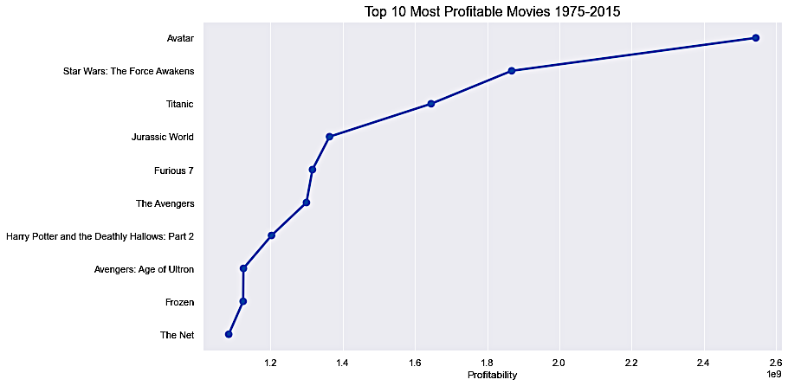

1. **Budget v Profitability (Top 500)**

There is no one-size-fit-all solution to the science of movie releasing. The ‘contollables’ (choice of stars, director, genre, general appeal, etc) are not actually so controllable in practice while the non-controllables are exactly that, causing chronic sleeplessness in the business until at least the first weekend’s revenue figures come in, telling them exactly what the paying public thought of their art .

However, it was potentially interesting to rank the top 500 releases in our dataset by budget and see does this show any clear pattern as it feeds into ‘Profitability’ (an extra column added to the dataset dividing revenue by budget).

The topline takeaway here is that most fall into an area where budget feeds into profit fairly comfortably. This indicates that for the best supported releases in terms of budget (this is the top 500) the studios read things reasonably well.

However, there are marked exceptions where some outperformed the budget/expectations set, while some clearly failed, actually losing money in spite of the upfront investment.

These fluctuations would obviously be very much more marked if the whole dataset was analysed, but it is interesting to map how this group performed.

# Summary of Insights

1. Based on the template crated by the success of Jaws and accelerated by the investment in quality, multiplex cinemas, the number of releases has increased Y on Y from 1975 to 2010, with only a small drop-off up to 2015.
2. The studios and distributors clearly use the full calendar year for releases, not just dropping the highest profile output into the holiday seasons.
3. The genre mix has largely evolved in a manner best positioned to follow the money with high budget, wide appeal dram/action, etc. titles making up the bulk of total releasing.
4. The high cost, potentially high box office titles dominate the top 10 all time earners. However the list can be crashed by titles such as The Net which earned many times its upfront investment for reasons not built in to initial projections (although, it was probably Sandra Bullock’s growing star power on the back of the success of Speed).
5. The ‘science’ of movie releasing means that many releases will cover or exceed their upfront investment although there are many exceptions to this apparent trend.

# Geopandas Mapping

1 Simple Place map of all Distilleries – Island of Ireland

The number of whiskey distilleries in Ireland had fallen from circa 40 in the late 1800s/early 1900s to essentially 3 by the mid 1980s.

Recent years have seen a renaissance for Irish Whiskey with an ever increasing share of the national and international spirits market and with sales in the US actually anticipated to outstrip those of Scotch by 2030 (<https://www.thespiritsbusiness.com/2020/12/irish-whiskey-sales-forecast-to-exceed-scotch-by-2030/>).

Although the initial heavy lifting, sales-wise has been by Irish Distillers, it is the growth of new, often independent distillers that is taking the product to new heights. This is driving investment in new distilleries and, while there is some dispute about how many are active or due to come on line, this would seem to be in the 40+ range.

In an effort to establish the true number and express their geographic spread we found a dataset that seemed to be the best measure available. It lists 45 distilleries spread right across the island (Note that two, Kinahan’s and Thomond Gate did not have longitude/latitude figures on the dataset so are naturally not included on map):

Map1

Dataset from <https://oralytics.com/2020/02/24/irish-whiskey-distilleries-data-set/>

2. Interactive Map of East Coast and Munster Distilleries

As the static map before is rather cluttered on the East Coast, especially around Dublin, and also in Munster (10 distilleries) I have constructed an interactive map covering these areas specifically.

The link to the map file is below:

<https://github.com/Martmedia/UCDPA_MartinCody/blob/main/EastCoast.html>

Note: File (EastCoast.html) needs to be downloaded locally and then and opened with browser.

# References

**Movies Dataset:** <https://www.kaggle.com/juzershakir/tmdb-movies-dataset?select=tmdb_movies_data.csv>

**Jaws**: <https://www.indiewire.com/2017/06/jaws-modern-blockbuster-steven-spielberg-1201844390/>

**Whiskey Dataset**: <https://oralytics.com/2020/02/24/irish-whiskey-distilleries-data-set/>

**Documents on GitHub relating to project:**

**Main Project:**

tmdb_movies_data.csv – Raw data set for analysis

Martin Cody Project BETA.ipynb – Jupyter notebook, overall project code

**Geopandas**

Irish_Whiskey_Distilleries.csv – Dataset mapped using Geopandas

Martin Cody Geopandas 1.ipynb – Jupyter analysis of dataset.

EastCoast.html – Interactive map outputted from Jupyter